Project Proposal - Group 5 -

Ravindra Patel | Julie Plye | Oulsegun Olorunfemi | Jon Zagorski

Roles:

Julie : Team Lead - guiding the team through the code

Ravindra : - Proposal and Read Me

Jon : Finding Data

Segun : Aws -

Team:

Clean the date and upload that data, Transfer the data to PosgreSQL, make visualization JS CSS and D3

**Goals -**

Create a data of visualization of the Election data from 2000 - 2016(2020 if the data is available) <ask Carol or Tom if the years range is enough>

Create 3 maps: “ **Heat Map** of the voter count of each states” “**Choropleth map** to show which graph was Rep or Democrats” “**An interactive line graph** total # Are votes casted either going up or down? - See the trend

Map of the % of people/ population eligible to Vote - VEP- Voting Eligible Population

Get the data for - Totals votes casted in each state (Ex: Alabama had ## amt of people voted in 2016) <see if this work>

**Base Graphs**

Use One graph from a leaflet that we have not used yet.

**Create the website** - and use that as a presentation which will tell a better story and more sufficient.

Sketch

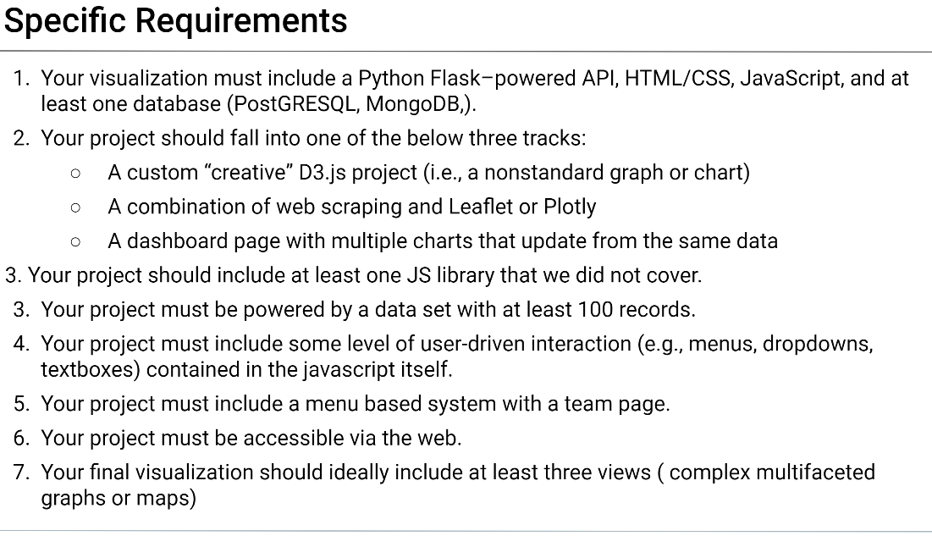

Draft:

What to create :-

**Show the Maps** - Which states are generally Republicans or Democrats

**Graph:** Showing some of the Swing states

**Drop Down menu** - with years and Range. - Voter turnout of the years

Base Graphs

Sources

<https://electionlab.mit.edu/data>

<http://www.electproject.org/home/voter-turnout/voter-turnout-data> - VEP